

**FACULTY OF COMPUTING AND INFORMATION SYSTEMS**

**DEPARTMENT: INFORMATION TECHNOLOGY**

**PROGRAMME: BSC. INFORMATION TECHNOLOGY**

**COURSE TITTLE: INTERNET TECHNOLOGY AND WEB DESIGN**

**LECTURER: DR. WILLIAM BROWN ACQUAYE**

**COURSE CODE: IT-343**

**STUDENT NAME: ALBERTA AKOSUA QUANSAH**

**STUDENT ID: 4215220148**

**LEVEL: 300 MORNING (GROUP D)**

**URL:**

**TABLE OF CONTENT:**

* Introduction………………………………………………Page 3
* Design………………………………………….……………Page 4
* Implementation………………………………………..Page 5-11
* Conclusion…………………………………………………Page 11

**INTRODUCTION:**

This report analyses the website created for Waawolo Food City, a basic restaurant specializing in local and continental cuisines. The website aims to provide a user-friendly online presence, allowing customers to learn about the restaurant's offerings and potentially make inquiries.

The primary objectives of the website are:

* **Establish an online presence:** Increase the restaurant's visibility by creating a digital footprint for potential customers searching online.
* **Showcase Restaurant Information:** Communicate essential details like the restaurant's name, cuisine types, and atmosphere.
* **Display Menu:** Present the restaurant's menu, allowing customers to browse available dishes and prices even before visiting the restaurant.
* **Facilitate Communication:** Provide a means for customers to contact the restaurant with inquiries or reservations (depending on the website's functionality).

The website targets a broad audience, primarily focusing on:

* **Local residents:** Individuals living or working near the restaurant, Ashaley Botwe, seeking convenient dining options.
* **People interested in local and continental cuisines:** Customers specifically searching for restaurants serving the restaurant's special cuisines like rice noodles with tofu and the Waawolo Gob3 Pro Max.
* **General online searchers:** Users who discover the website through online searches for restaurants in the area.

The basic functionalities of the website likely include:

* **Static Content:** Essential information like the restaurant's name, address, operating hours, and a brief description of the concept.
* **Menu Page:** A dedicated page showcasing the restaurant's menu items categorized appropriately (appetizers, main courses, desserts, etc.).
* **Contact Form:** A form allowing users to send messages to the restaurant with inquiries or reservation requests (depending on implementation).
* **Responsive Design:** The website is responsive, adapts its layout to display optimally on various devices (desktops, tablets, smartphones).

**DESIGN:**

This is a sitemap for the website created for Waawolo Food City.

On the home page, you’ll see a header with the Waawolo Food City banner along with ‘About’, ‘Menu’ and ‘Contact’ on it. When you click on About, Menu or Contact, you’ll be directed to a separate webpage. These three options are linked to three individual webpages in the website.

Below that, there is a greeting message and a paragraph which tell us a little about Waawolo food city and their opening hours.

A photograph of the Waawolo Food City restaurant interior is displayed afterwards. This shows a group of happy customers dinning in the restaurant.

This is followed by several pictures of some of Waawolo Food City’s cuisines and menu items.

Three social media links of the restaurant are provided below the pictures of the menu items; each link when clicked, directs the user to another webpage which is either of their social media pages.

Waawolo Food City’s contact numbers are displayed below the social media links.

A footer is included to the homepage displaying Copyright Waawolo Food City – 2024.

**IMPLEMENTATION:**

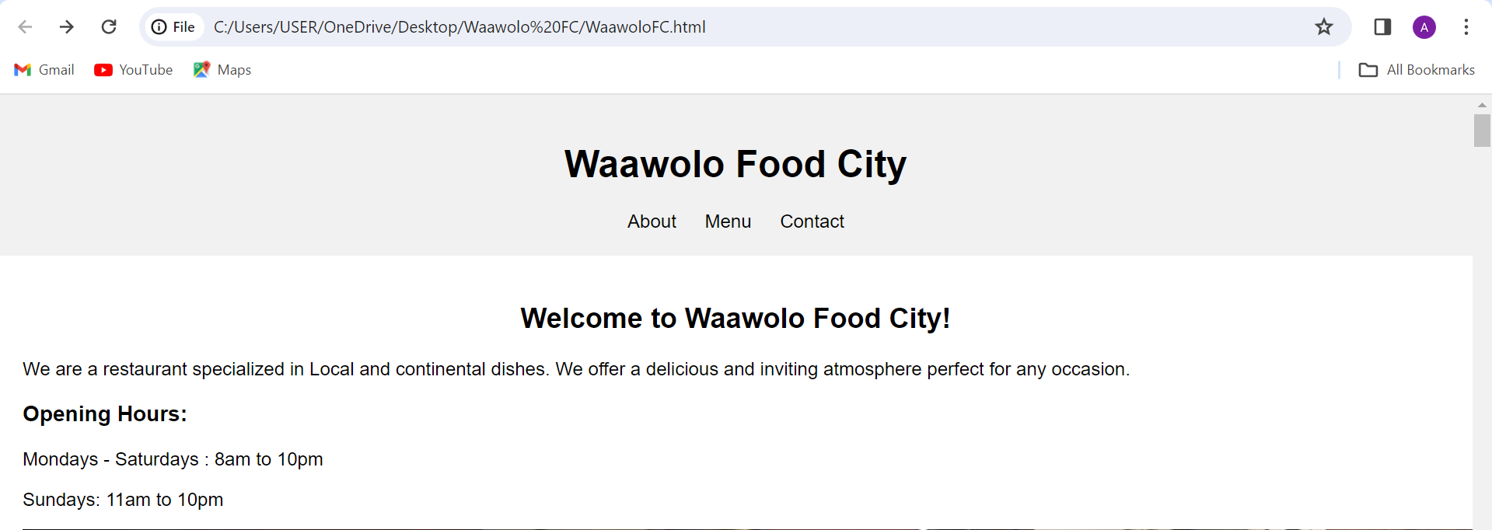

Fig. 1.0

Fig. 1.0 shows the first part of the homepage of Waawolo Food City. It does not display a the full info and history of Waawolo Food City because that information will be displayed in the ‘About’ webpage.

This page gives the user a fair idea of the restaurant’s name, cuisine types and available hours for operating.

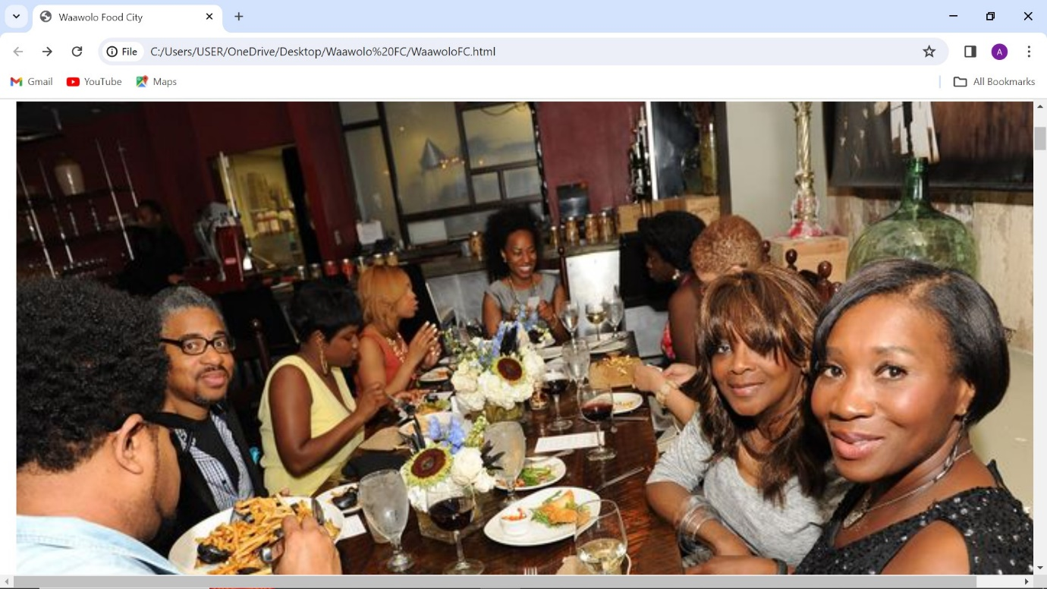

Fig. 1.1

Fig. 1.1 displays a photograph of some of the customers of Waawolo Food City dinning inside the restaurant.

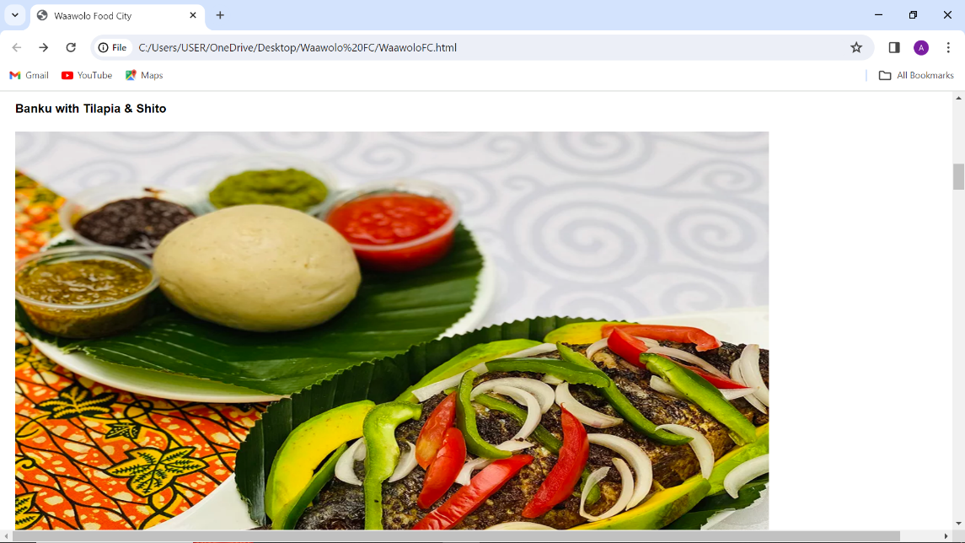

Fig. 1.2

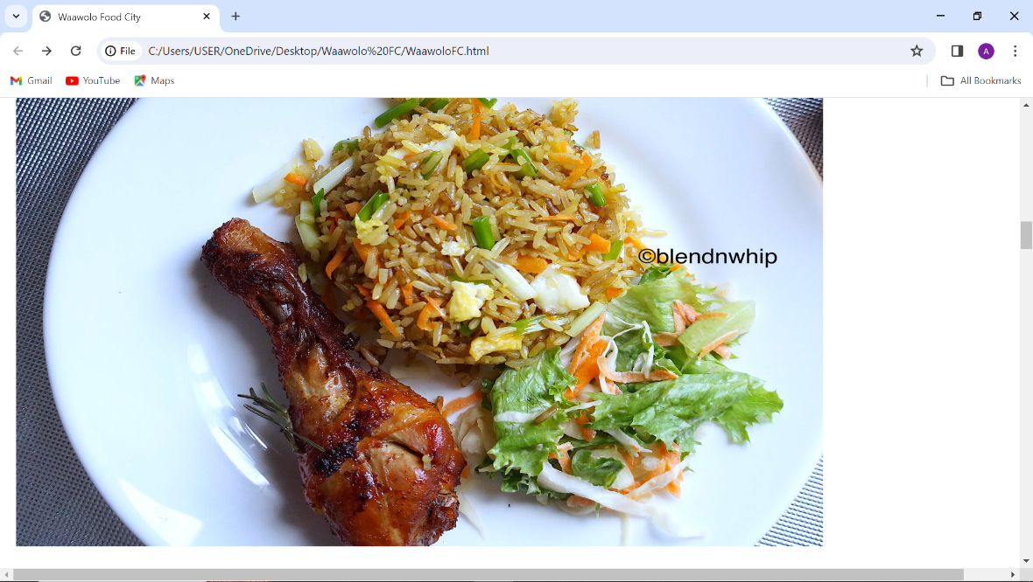

Fig. 1.3

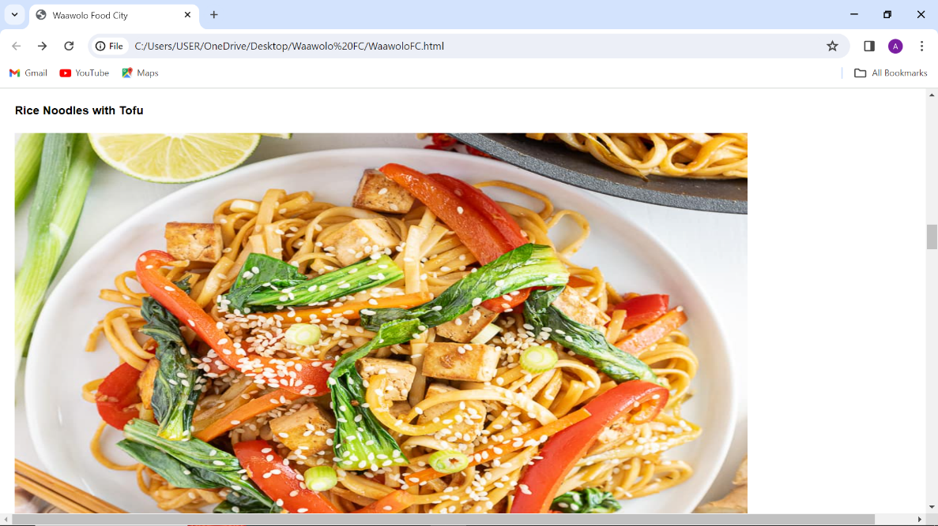

Fig. 1.4

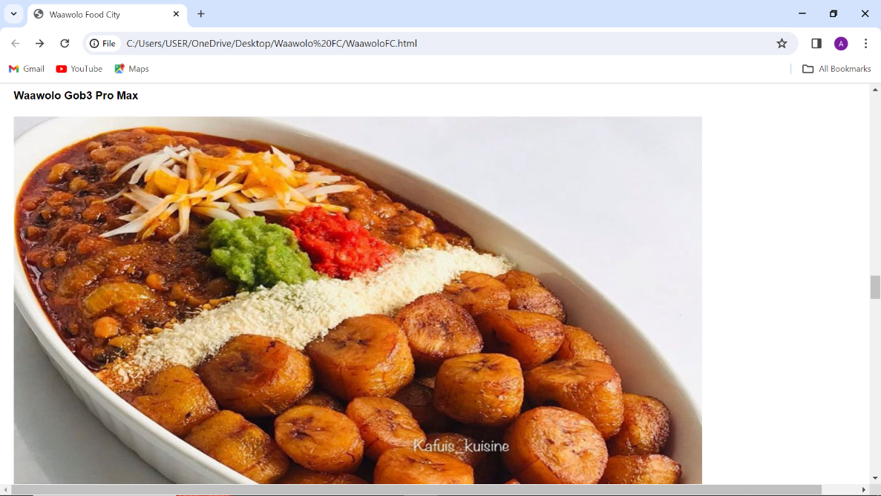

Fig. 1.5

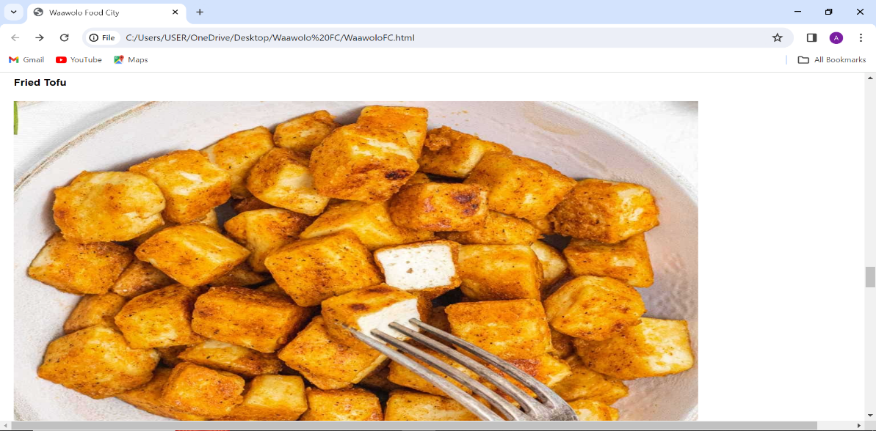

Fig. 1.6

Fig 1.2, 1.3, 1.4, 1.5, 1.6 shows photographs of some of the menu items of Waawolo Food City.

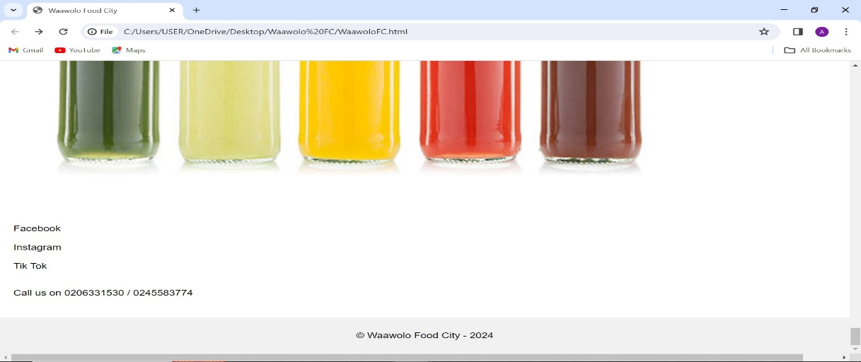

Fig. 1.7

Fig. 1.7 shows a portion of a menu item, Waawolo Food City’s social media links, Waawolo Food City’s telephone numbers and a footer with Copyright Waawolo Food City.

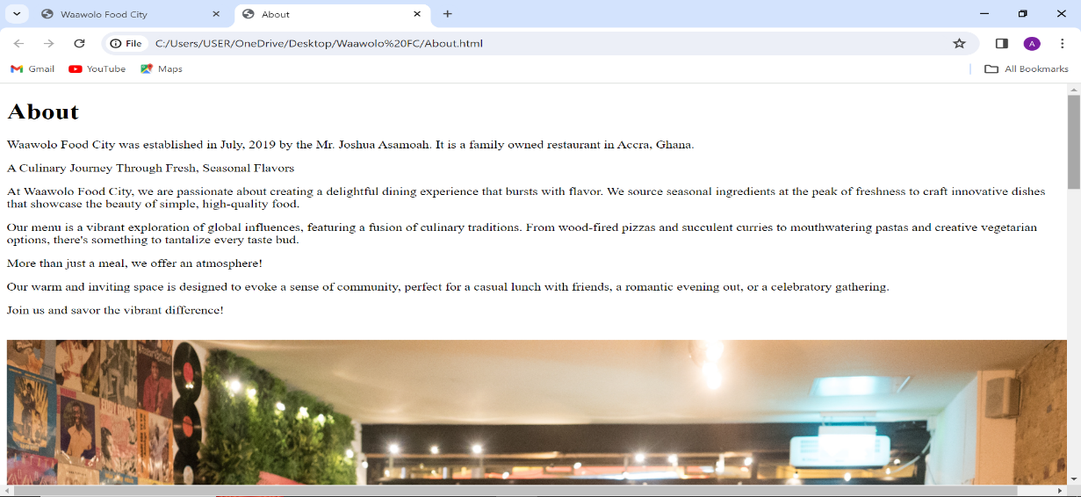

Fig. 1.8

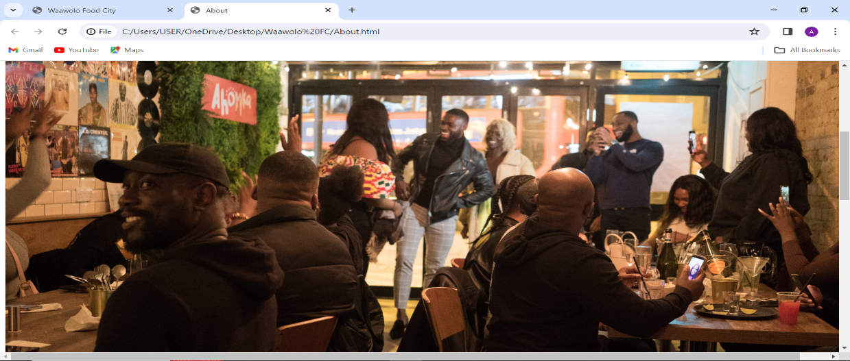

Fig. 1.9

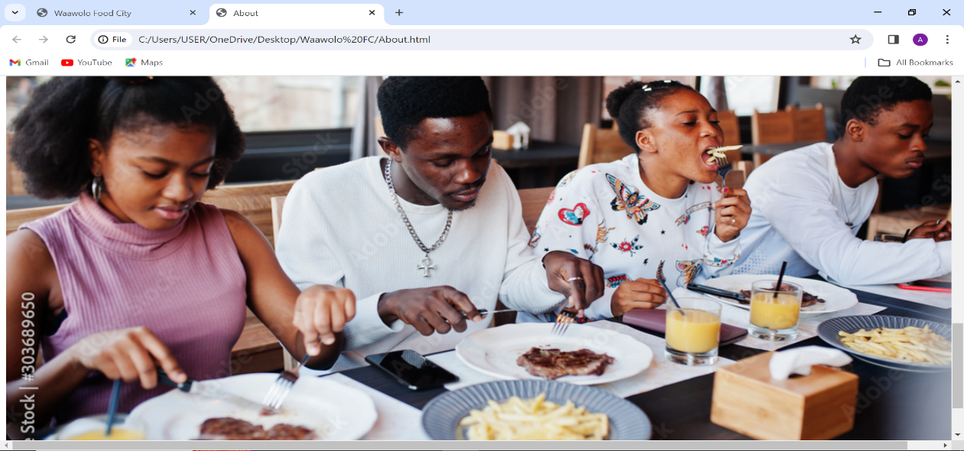

Fig 2.0

Fig 1.8 shows a screenshot of the webpage the user will be directed to when the ‘About’ tab is clicked. This webpage provides a history of Waawolo Food City, its owners and the services they provide.

Fig1.9 and Fig 2.0 displays pictures of some of the customers dinning in the restaurant and this can be found on the ‘About’ webpage.

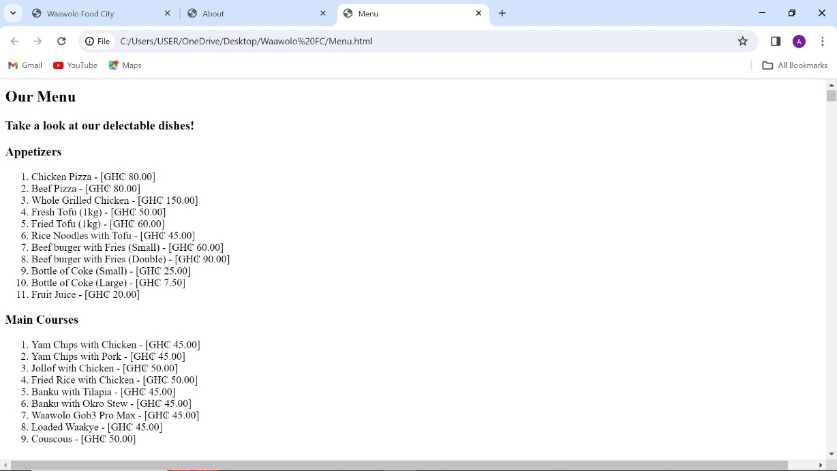

Fig 2.1

Fig 2.1 shows a screenshot of the webpage the user will be directed to when the ‘Menu’ tab is clicked. This displays the various menu items with their prices respectfully.

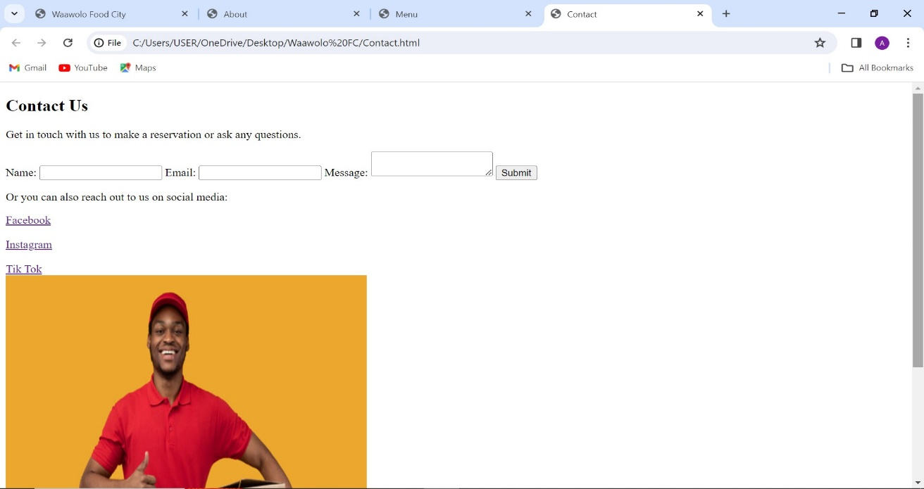

Fig. 2.2

Fig 2.2 shows a screenshot of the webpage the user will be directed to when the ‘Contact’ tab is clicked. This webpage contains a form which can be filled by the user to place an order, make a complaint or make an enquiry about Waawolo Food City.

It also has the social media links of Waawolo Food City which will direct the user to the social media pages of Waawolo Food City.

**CONCLUSION:**

This report has analysed the website created for Waawolo Food City, a basic restaurant specializing in local and continental cuisines. The analysis focused on the website's effectiveness in achieving its objectives of establishing an online presence, showcasing restaurant information, displaying the menu, and facilitating communication. **Overall, the website provides a basic online presence for** Waawolo Food City.